# This Is To Certify That

**Completed the NYSED/NYSDOH Approved Webinar:**

**Managing Allergies and Anaphylaxis at School: Training for Unlicensed School Personnel**

# on

This certificate is valid only if signed by the school professional identified by school administration to review the Posttest Completion and Skills Check.

**NOTE:** If training applies to administering EAI to students **with an order for medication for a specific allergen(s) this must be a NYS RN, PA, MD/DO.**

Signature:

Title:

Date:

Valid for One Year From Date of Issue  
  
Monroe 2-Orleans B OCES is recognized by the New York State Education Department as an approved  
 Sponsor of Continuing Teacher and Leader Education ( CTLE)

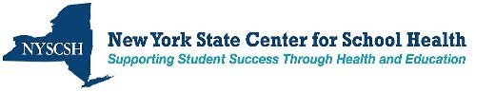

One hour of CTLE credits are a warded for this activity. The CTLE # for this activity is 664