**Sample School Guidelines for Cold Weather Safety**

There is nothing in NYS law or regulation about outdoor temperatures (hot or cold). The decision for school closure or modifying outdoor activities is made at the local school district level. School districts may utilize this information to assist in making decisions about modifications of outside activities or school closures; understanding severe climate conditions where temperatures and wind chill dip into certain extreme ranges can cause medical concerns for the safety of students.

## Background Information on Temperature and Potential Effects

* The National Weather Service (NWS) begins to issue ADVISORIES when wind chills of -15°F are predicted and WARNINGS when wind chills of -25°F are predicted. Criteria for issuing official NWS Extreme Cold Warnings and Cold Weather Advisories are set locally.
* Frostbite can occur in children even before temperatures and wind chills dip into these extreme numbers due to smaller body size and weight and inadequate or wet clothing.
* When the air temperature is above freezing, hypothermia could occur.
* When the air temperature is below freezing, the risk of frostbite injury is determined by the combination of temperature, wind speed, and exposure time.

School Administration should consult the [National Weather Service Wind Chill Chart](https://www.weather.gov/safety/cold-wind-chill-chart) to determine when conditions are too risky for safe outdoor activity. * The wind chill chart should be utilized as a starting point and be even more cautious with children.

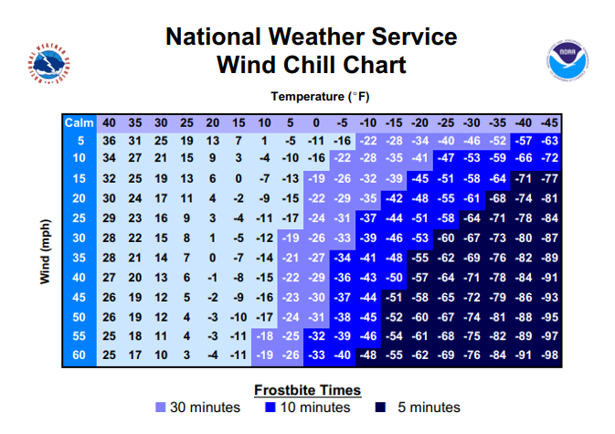

* The tests that were done on wind chill were conducted on adult subjects. For legal and safety reasons, NWS did not ask for child volunteers. Use the existing chart as a starting point and be even more cautious with children, the elderly, and persons with compromised health.

## Strategies to Decrease Risk of Injury from Severe Weather

* Educate staff and students regarding prevention, identification, and care of cold weather injuries.
* Instruct students to alert an adult if they are experiencing cold weather-related concerns.
* Educate parents regarding prevention, risk strategies, and notifications through newsletters, district websites, and media outlets.
* Modify bus arrangements and outdoor activities to accommodate weather emergencies.
* Modification or suspension of outdoor activity, including all interscholastic outdoor sports.
* Closure or late arrival in districts where students may have longer walking distances or wait times at bus stops.
* Monitor temperature extremes throughout the school day.

When wind chills are below 20°F, consider suspending outdoor activities, including outdoor sports, physical education, clubs, and playground/recess.

The NYS Public High School Athletic Association utilizes the following Wind Chill Procedure chart to

adjust athletic schedules. Districts may reference this chart when deciding to modify outdoor activities.

[Safety - New York State Public High School Athletic Association](https://nysphsaa.org/sports/2021/6/8/safety.aspx)

Additional cold weather resources, including educational resources for staff, students, and families, can be found on our [Weather | Safety | Planning](https://www.schoolhealthny.com/site/default.aspx?PageType=3&ModuleInstanceID=213&ViewID=7b97f7ed-8e5e-4120-848f-a8b4987d588f&RenderLoc=0&FlexDataID=178&PageID=163) resource page.