Sample School Guidelines for Hot Weather Safety

There is nothing in NYS law or regulation about outdoor temperatures (hot or cold). The decision to modify or suspend outdoor activities is made at the local school district level. School districts may utilize this information to assist in making decisions about modifications of outside activities; understanding severe climate conditions where temperatures and humidity rise into certain extreme ranges can cause medical concerns for the safety of students.

Background Information on Temperature and Potential Effects
- The Heat Index is a measure of how hot it really feels when relative humidity is factored in with the actual air temperature.
- Criteria for extreme heat watches and heat warnings are issued at the local level.
- Both lower temperatures with extremely high humidity as well as extremely high temperatures with low humidity can place a student at risk.
- Heat can be very taxing on the body and can lead to heat-related illnesses or make existing health conditions worse.
- Young children and those with chronic medical conditions are particularly vulnerable to heat-related illnesses.
- The heat index values below were devised for shady, light wind conditions. Exposure to full sunshine can increase heat index values by up to 15°F. Strong winds, particularly with very hot, dry air, can be extremely hazardous.

School Administration should consult the National Weather Service Heat Index Chart to determine when modifications are needed for safe outdoor activity.
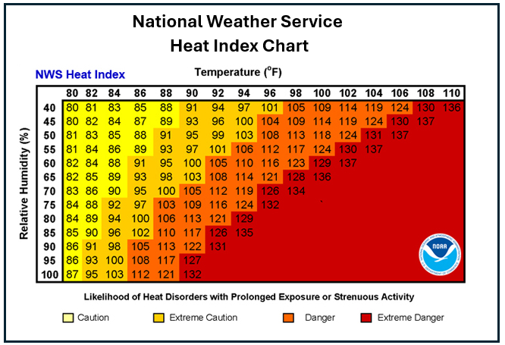

Strategies to Decrease Risk of Injury from Severe Weather
- Educate staff and students regarding prevention, identification, and care of heat-related illnesses/injuries.
- Instruct students to alert an adult if they are experiencing hot weather-related concerns.
- Educate parents regarding prevention, risk strategies, and notifications through newsletters, district websites, and media outlets.
- Modify or suspend outdoor activity, including all interscholastic outdoor sports.
- Monitor temperature extremes throughout the school day.

The NYS Public High School Athletic Association utilizes the following Heat Index Procedure chart to adjust athletic schedules. Districts may reference this chart when deciding to modify outdoor activities.
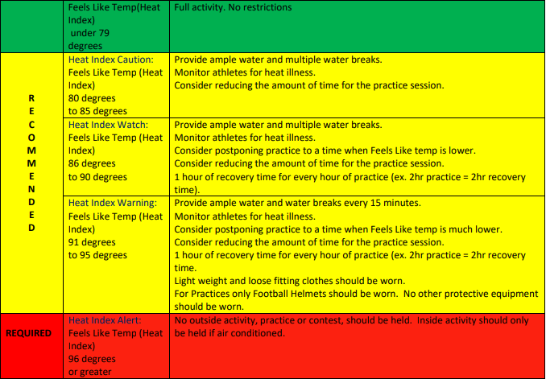

Safety - New York State Public High School Athletic Association

Additional hot weather resources, including educational resources for staff, students, and families, can be found on our Weather | Safety | Planning resource page.

